**NAAN MUDHAVAN**

**ASSIGNMENT DOCUMENT**

**COURSE TITLE :** DIGITAL MARKETING

**COLLEGE CODE :** 1105

**COLLEGE NAME :** GOJAN SCHOOL OF BUSINESS AND TECHNOLOGY

**NM ID :**050ED93DAAD6921A6254F1CCD666CCBB

**NAME :** VEDAVALLI.R

**REGISTER NUMBER :** 110520106021

**YEAR :** 4TH YEAR

**DEPARTMENT :** ELECTRONICS AND COMMUNICATION ENGINEERING

1. Create a blog or website using Blogspot and Wordpress. Customize the theme design And post new article with 500 words.

Link: <https://boostimmum2023.blogspot.com/2023/10/the-nutrition-station>

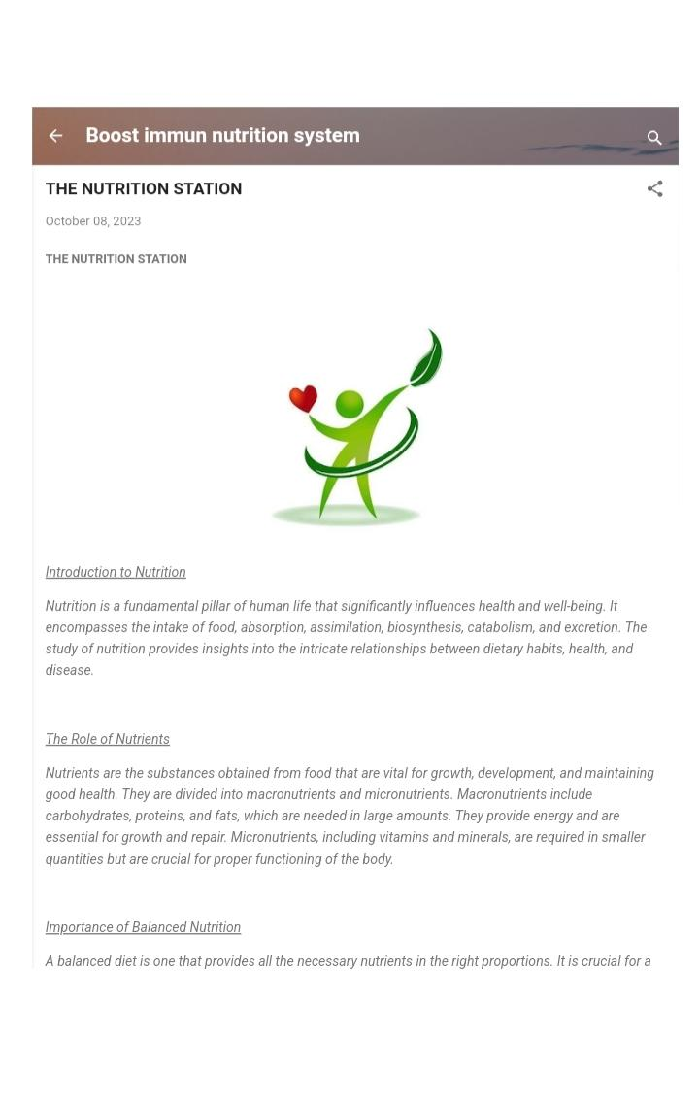

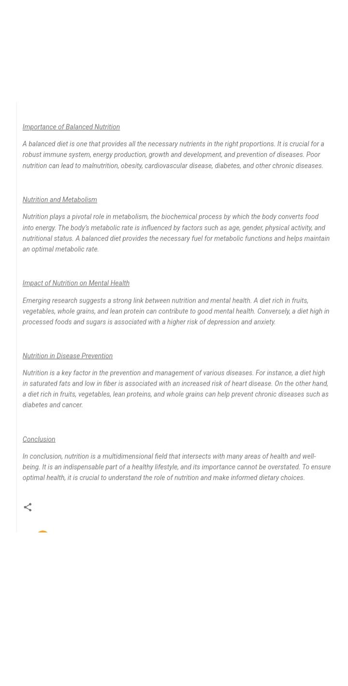

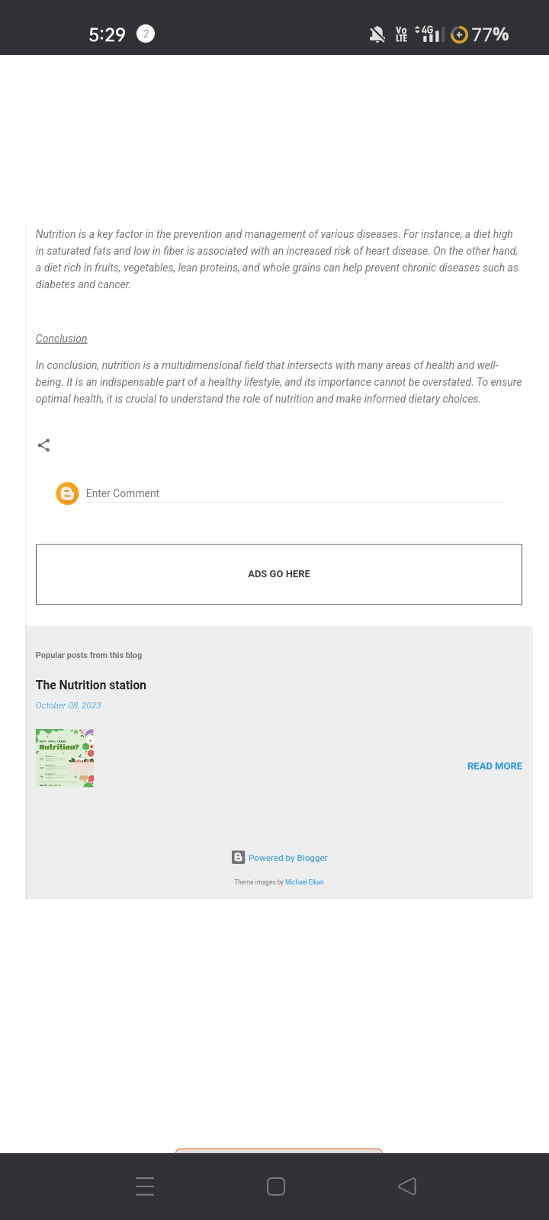

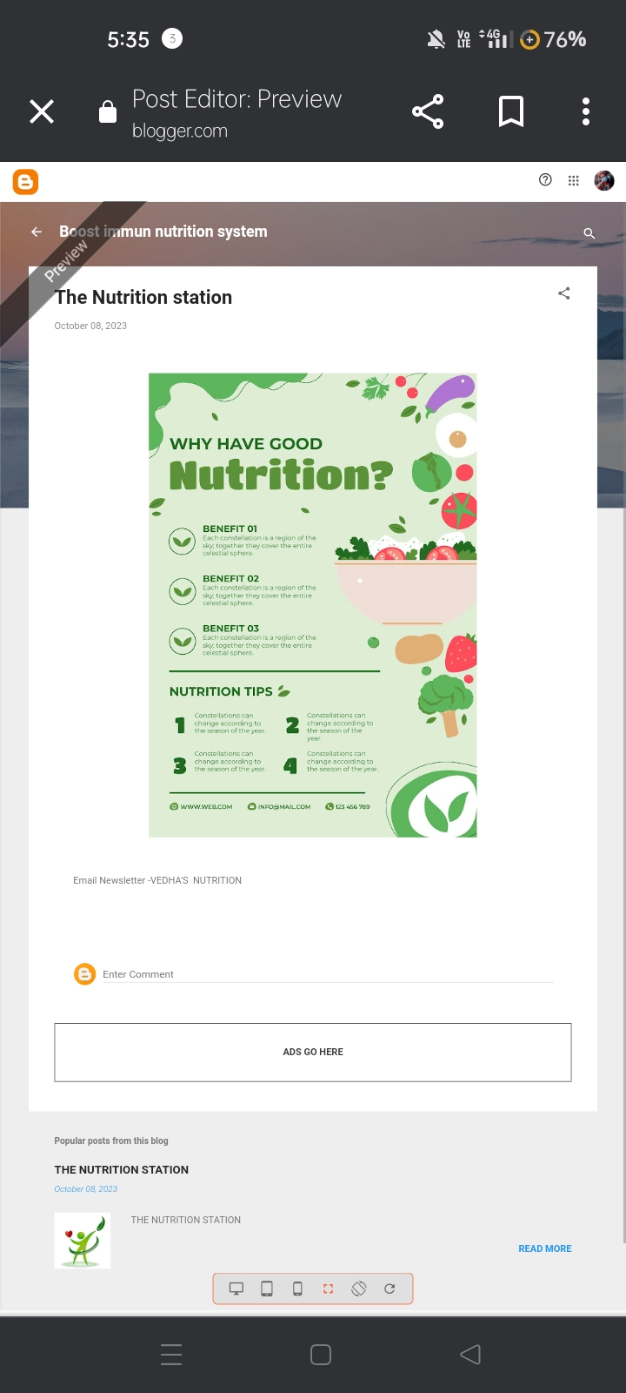

2. Create a New Facebook Business Page and post one social media poster for your

Brand.

Link: <https://www.facebook.com/profile.php?id=61552081474810&mibextid=ZbWKwL>

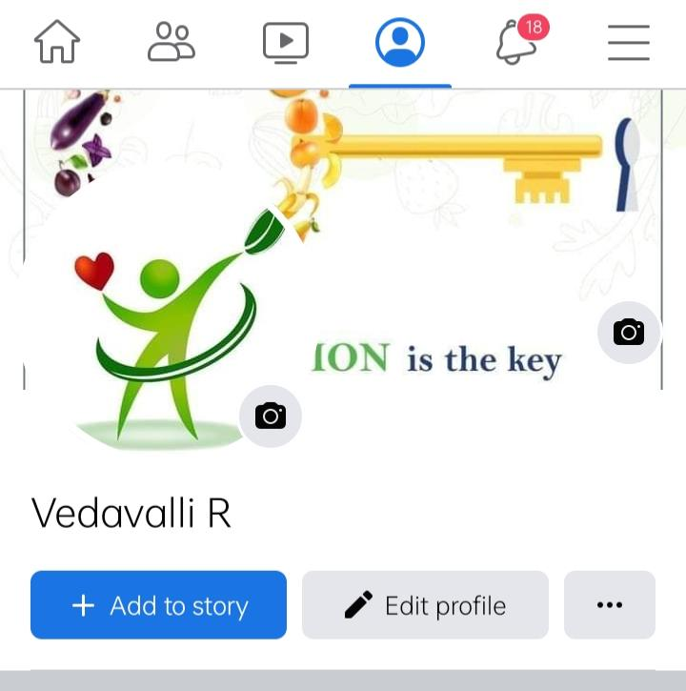

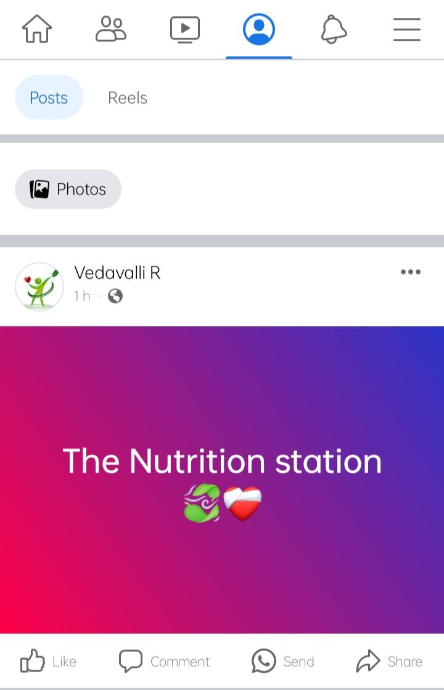

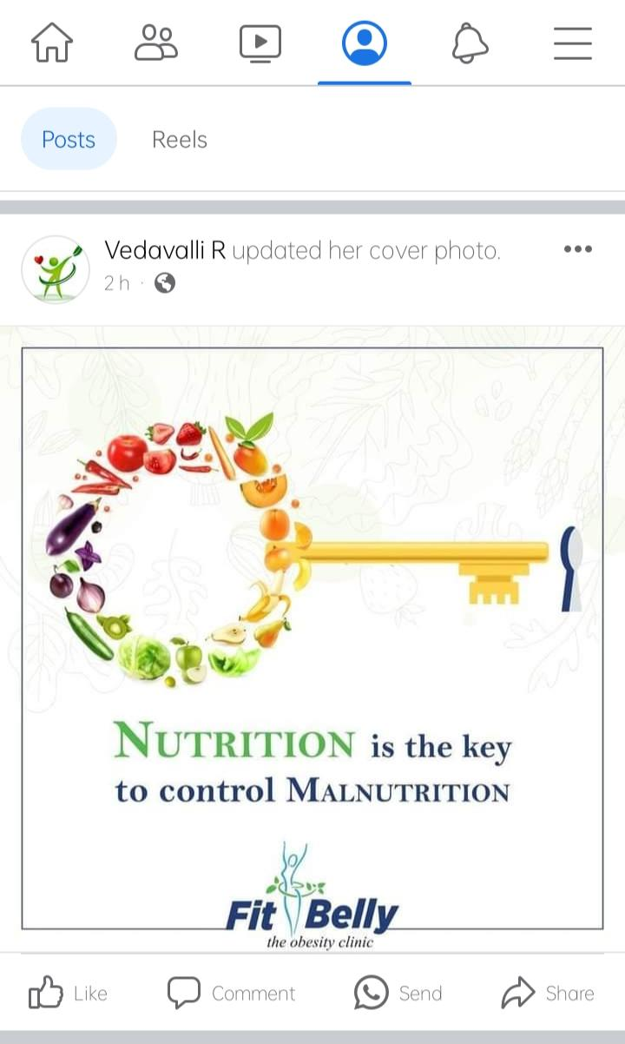

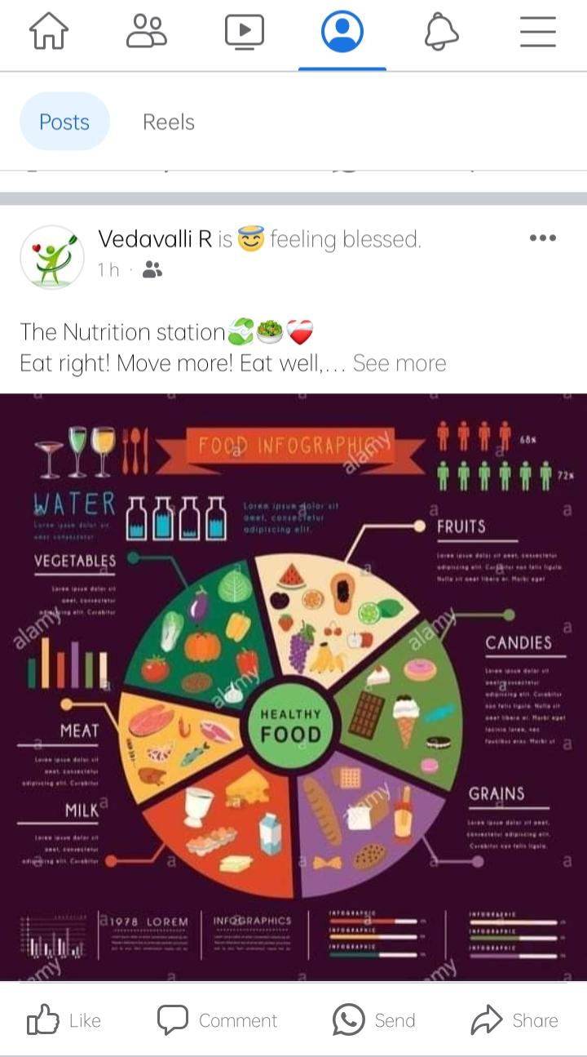

3. Create and design a social media advertisement poster using canva.

<https://www.canva.com/design/DAFx_VrjjKI/ccFseaqWEI8ShcvIcM8p1A/edit?utm_content=DAFx_VrjjKI&utm_campaign=designshare&utm_medium=link2&utm_>



4. Create email newsletter design using Mail chimp or canva tool.

Link:

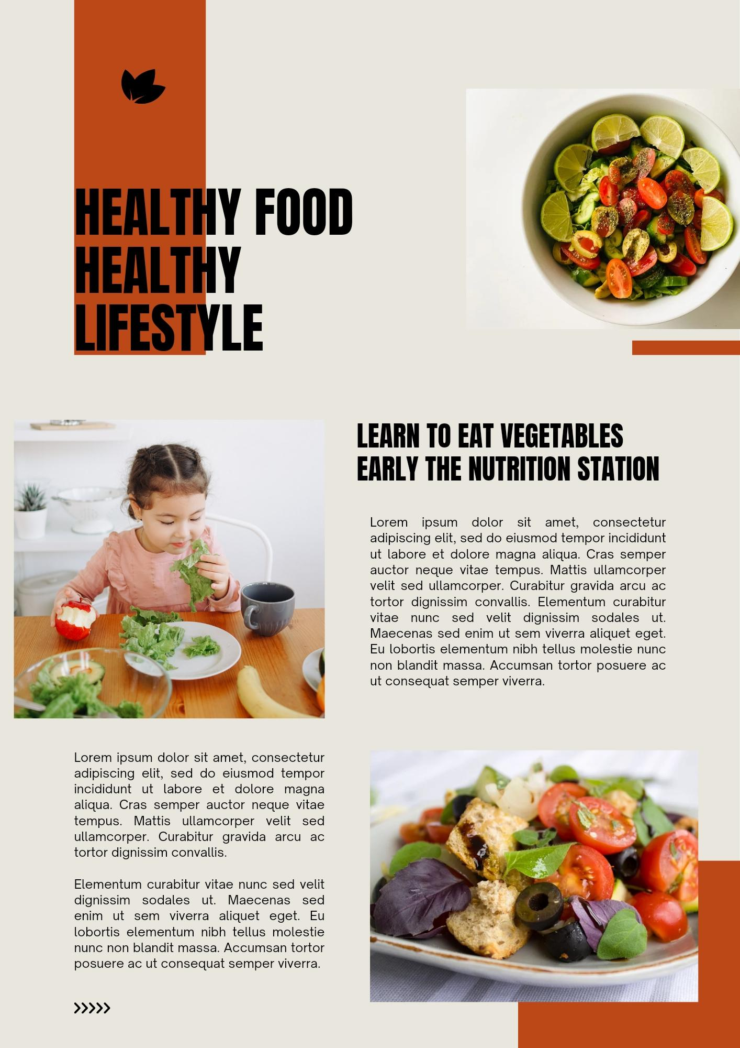https://www.canva.com/design/DAFx_TxXcqk/Cyda_CNm_vVvv4CUGMOM7Q/edit?utm_content=DAFx_TxXcqk&utm_campaign=designshare&utm_medium=link2&utm

